Object Detection Using YOLO
Project Overview:
To build an object detection system using YOLO. The task is to collect data of three objects: Red cup, Blue bottle and a Mobile. Label the images by drawing bounding boxes around each image. Then, generate dataset and export it into a format data.yaml and feed it to YOLO model for training. Once, the model is trained, use it for prediction in real-world using a webcam.

Data Collection:
Collected Images from the Web for the three objects “red cup, blue bottle & mobile”. Collected data from Pexels, Pixabay, Unsplash and Google. Images collected should have objects captured from different angles and distances, in different lighting conditions, and with varied backgrounds. Sometimes photograph a single object, and sometimes multiple objects together so they overlap or partially hide each other. This variation is important because it teaches the model to recognize objects in realistic conditions rather than memorizing one view.

Data Annotation:
Roboflow was used in annotating and preparing the dataset.
- Sign-In to Roboflow and Create a free account..
- Create a new project and select Object Detection.
- Upload all the image files that need to be annotated.
- Click annotate and Assign to start the manual labelling process.
- In each image, Click and drag a tight box around your object and type a name for label and save.
- After all the images are labelled, generate a dataset.

Dataset Generation:
- Preprocessing: Auto-resize all images to a standard size (e.g., 640 X 640 pixels) so they fit the YOLO input layer.
- Augmentation: To make your model more robust, you can create "synthetic" copies of your images by adding noise, flipping them, or changing the brightness.
- Export in YOLO format: Choose YOLO26 and download Zip that contains images, labels and data.yaml file, it tells YOLO script where the images are and what the class names are (e.g., 0: mobile, 1: red cup, 2: blue bottle).
- Downloaded dataset structure:
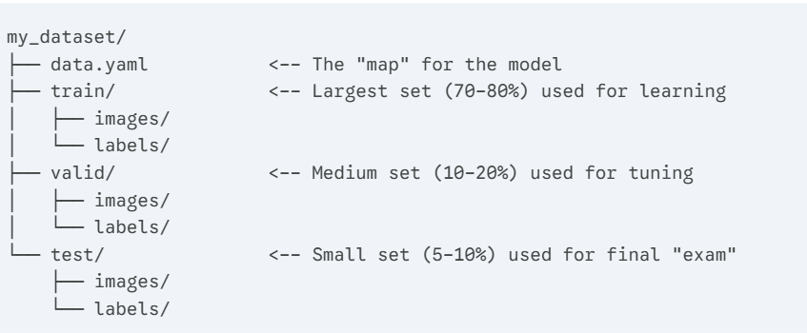
Each image file has a corresponding label file, each line represents one bounding box. YOLO uses normalized coordinates. This means every value is a ratio between 0 and 1, allowing the model to work even if you resize the image later.

Each line in the file represents one bounding box: Vector
0 0.512 0.380 0.124 0.210

Value | Meaning | Calculation
0 | Class ID | The index of the object (e.g., 0 for "phone", 1 for "red cup", 2 for “blue bottle”).
0.512 | Center X | The horizontal center of the box/ image width.
0.380 | Center Y | The vertical center of the box / image height.
0.124 | Width | The width of the box /image width.
0.210 | Height | The height of the box / image height.

Setting Up Environment:
Install the ultralytics library, which contains the YOLO engine, and the roboflow library to easily pull your data into your script.
Bash
pip install ultralytics roboflow

Connect Dataset and train the model:
Load a pre-trained model yolo26n.pt. Start training the model by specifying the dataset location data.yaml, epochs = 50, image size= 640 and plots= true.

Model Training Results:

1. The Confusion Matrix (The "Identity" Test)
- The Good: The model is excellent at identifying the blue_bottle (0.61) and Mobile (0.76).
- The Struggle: In the Red_cup row. There is a high value (0.44) in the "background" column. This means the model often looks at a red cup and thinks it's just part of the wall or table.
- Why? This usually happens if the red cup was too small in the photos or if there wasn't enough lighting contrast.
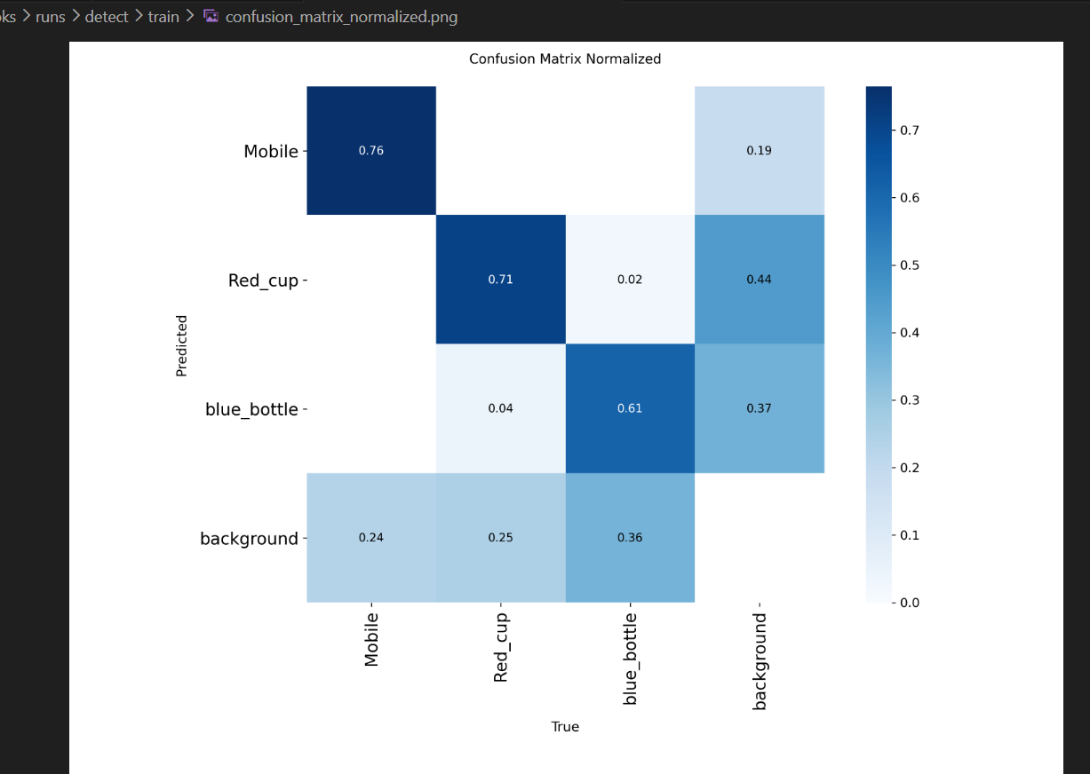

2. F1-Confidence Curve (The "Sweet Spot")
- Your F1 score peaks at 0.65 with a confidence of 0.338.
- What this means for code: When the code is run on webcam script, set conf=0.33 or conf=0.35. This is the mathematical "sweet spot" where there is best balance of catching objects without seeing too many "ghost" boxes.
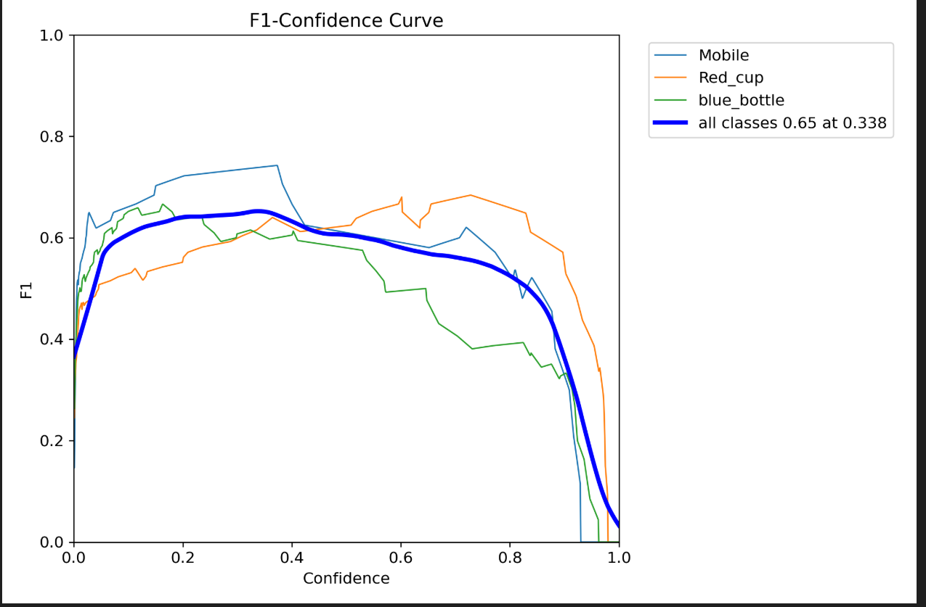

3. Precision-Recall Curve (The "Overall Grade")
- The mAP@0.5 is 0.673.
- In the world of custom YOLO models, anything above 0.6 (60%) is considered a "Passing Grade" for a first attempt. Mobile class is the "A student" at 0.717, while the blue_bottle is the "C student" at 0.617.
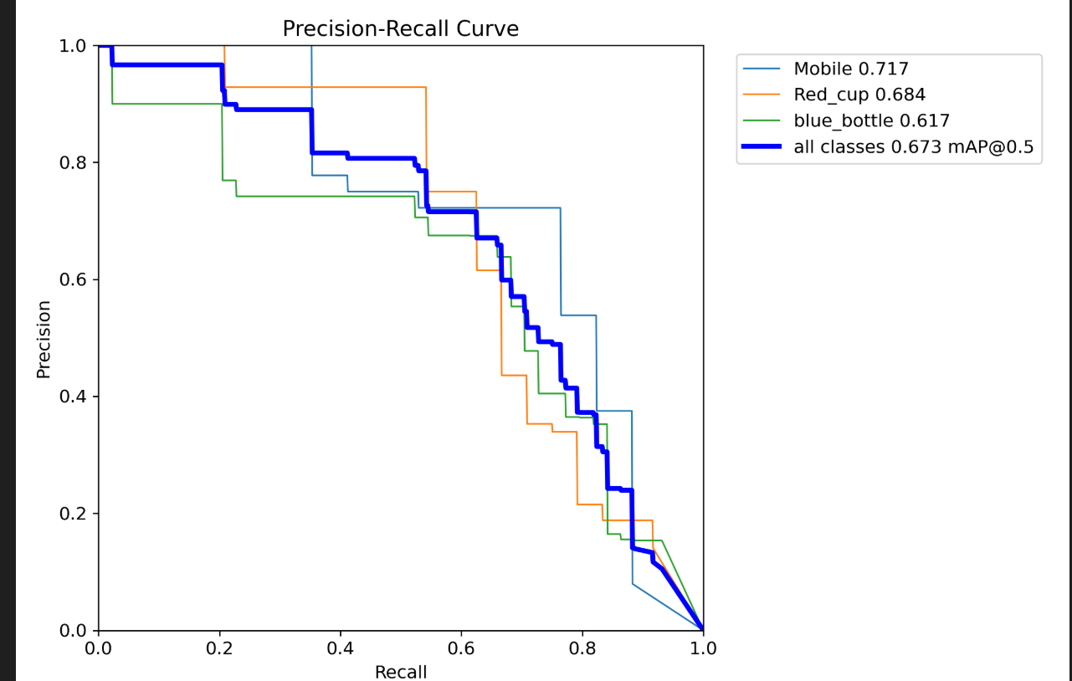

4. Training Graphs (The "Learning Process")
- train/cls_loss and val/cls_loss: Both curves dropped beautifully and flattened out. This confirms the model learned and didn't just "memorize" (overfit) the data.
- The mAP50 (bottom row, second from right) shows a steady climb and levels off right at the end of the 50 epochs. This tells that 50 epochs was the perfect amount of time—training for longer probably wouldn't have helped much more.
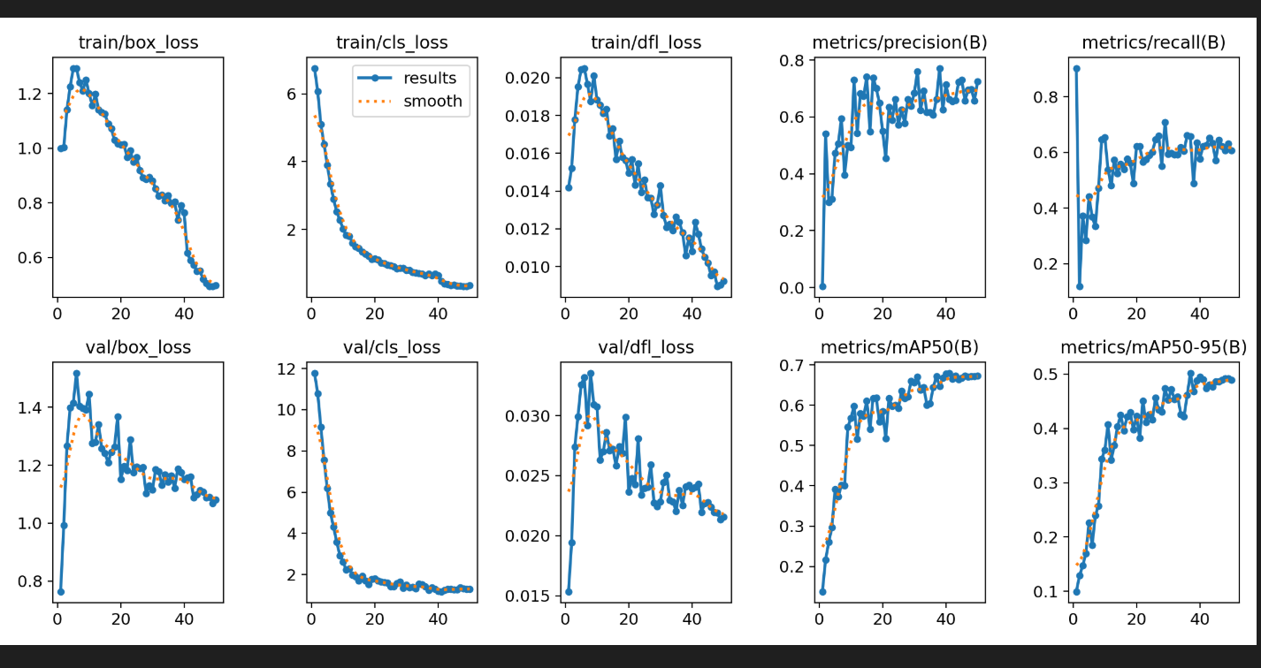

Summary Table
Metric | Value | Interpretation
Best Class | Mobile | Very distinct shape/features.
Weakest Class | blue_bottle | Likely gets confused with other vertical objects.
Optimal Confidence | 0.34 | Use model.predict() calls.
mAP@0.5 | 67.3% | Success! Great for a DIY home project.

Model Weakness:
The distant objects, blur objects, poor lighting and some angles of objects are failed to be detected. This means the model should be trained with more objects of these above categories to improve performance.

Real-time Detection on Webcam:
It works perfectly as trained and detects objects at realtime in a webcam and the video is recorded and saved in a file along with timestamp.
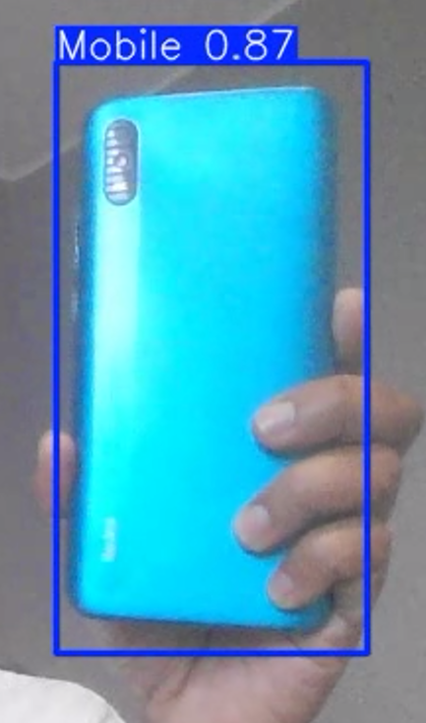
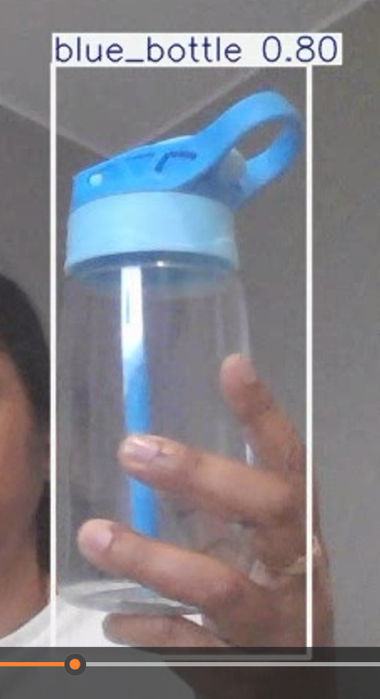
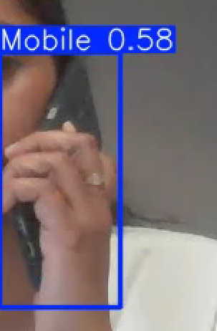

Group Project by :
Bharathi Dibbidi,
Nidhi Sharma,
Saranya Prabhu,
Shalu Prakasia

